SOCIAL STUDIES
GRADE: V DATE: 2.12.20
WORKSHEET – 15

15. TOWARDS FREEDOM
I. Complete these sentences
1.Once the British were firmly established in India, they started exploiting the
________________________________________________________________

2.The English East India Company made profit by buying

3.The first war of Independence was started by the

4.After the revolt was suppressed ,the administration of India

5. The social reformers in India strongly protested against social practices such as

II. Look at the picture and answer the questions
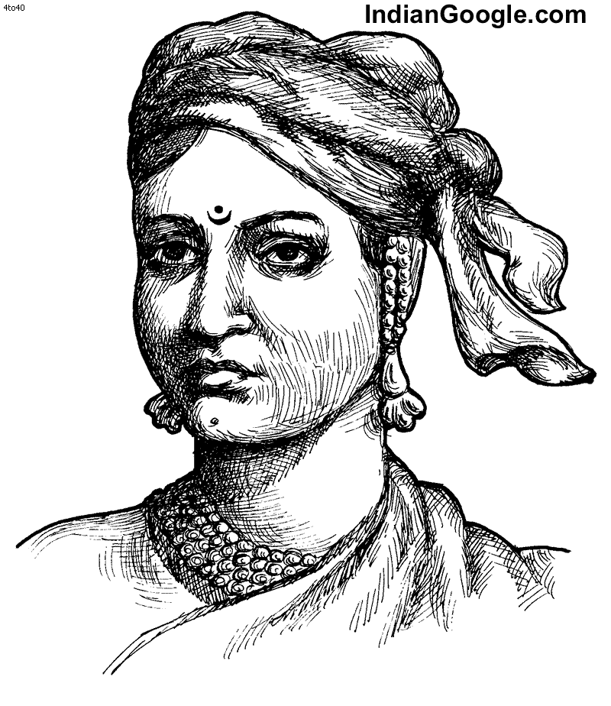

1. Who is this person?

2.What was her contribution to our struggle for Independence?

